**Assignment 5**

1.Write a program to swap two numbers in java.

<https://codeshare.io/9OLNmB>

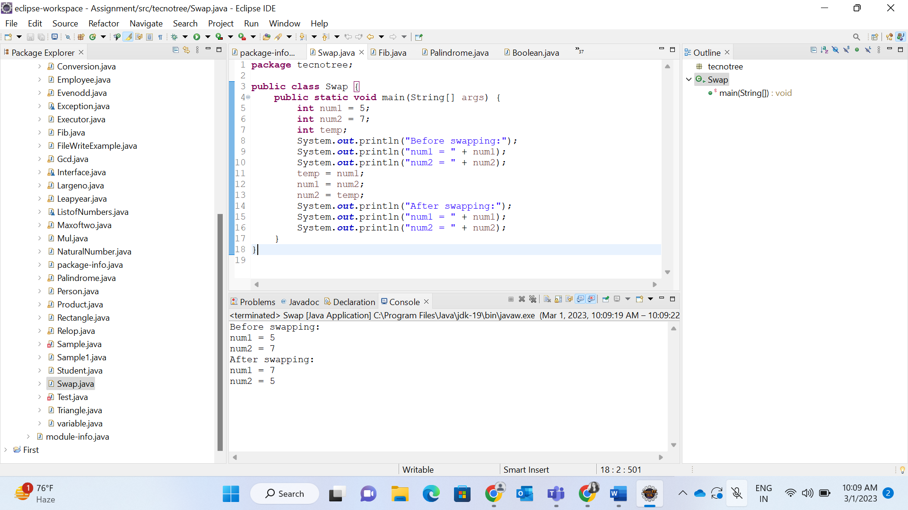

2.Write a java program to print the Fibonacci series.

<https://codeshare.io/bvOy7V>

3.Write a java program to check whether the number is Palindrome or not.

<https://codeshare.io/Ad1NEv>

4.Write a java program to check whether the number is Armstrong number or not.

<https://codeshare.io/6pkMXk>

5.Write a Java program to print the GCD of two numbers.

<https://codeshare.io/N3p09o>

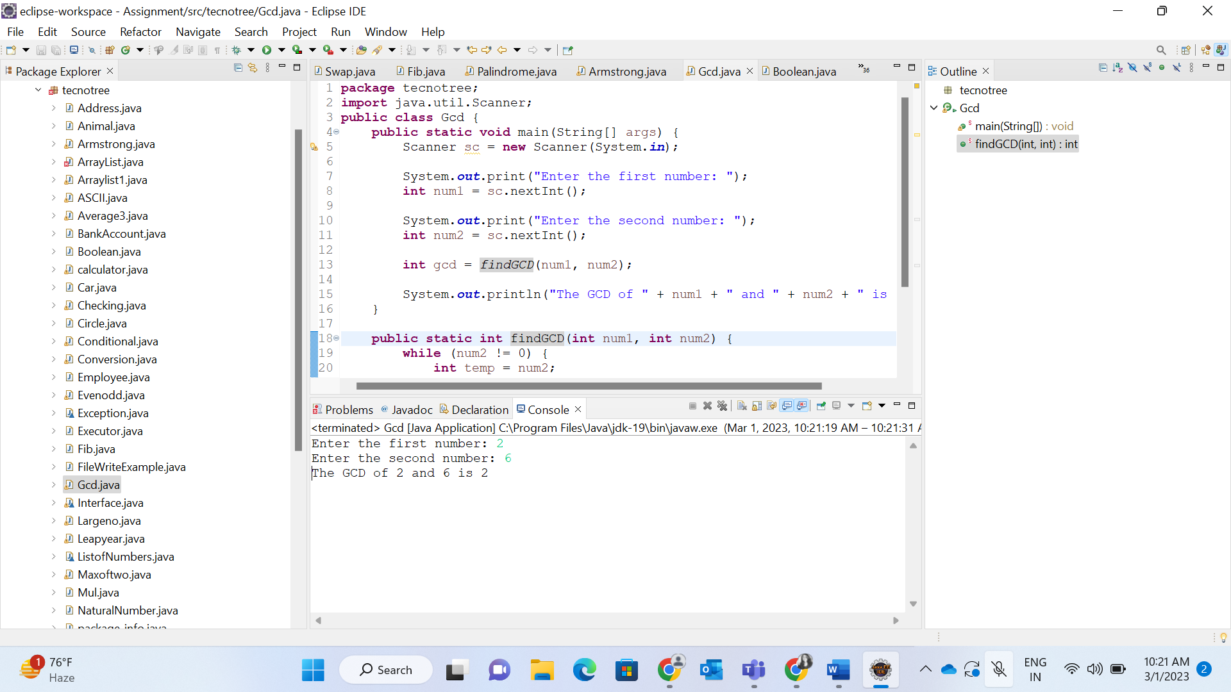

6.Write a java program to print the sum of n natural numbers.

<https://codeshare.io/8plMZ4>

7.Write a java program to print the LCM of two numbers.

<https://codeshare.io/X8E0mj>

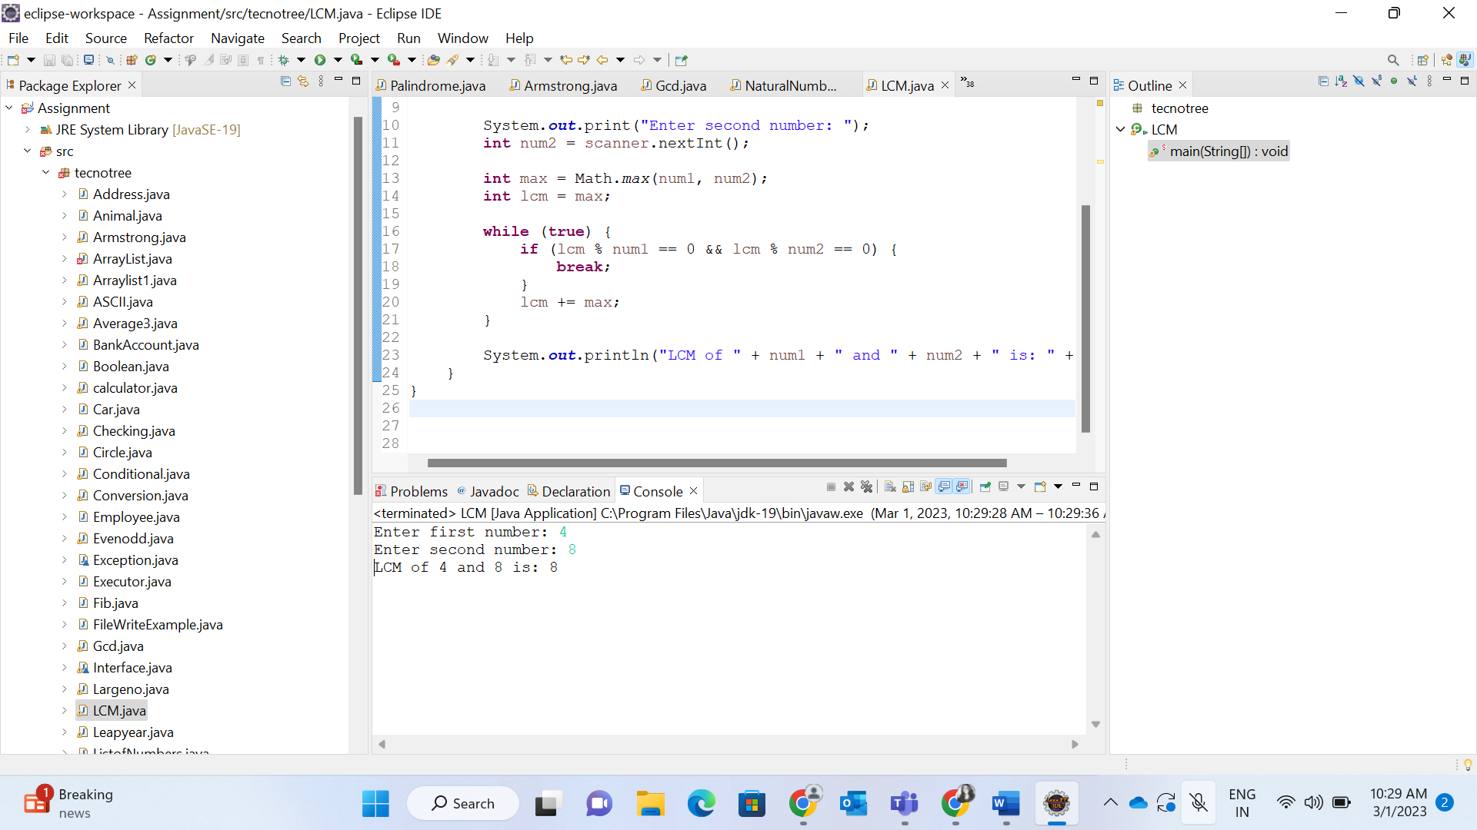

8.Write a java program to calculate the sum of digits of given number.

<https://codeshare.io/yo0Aww>

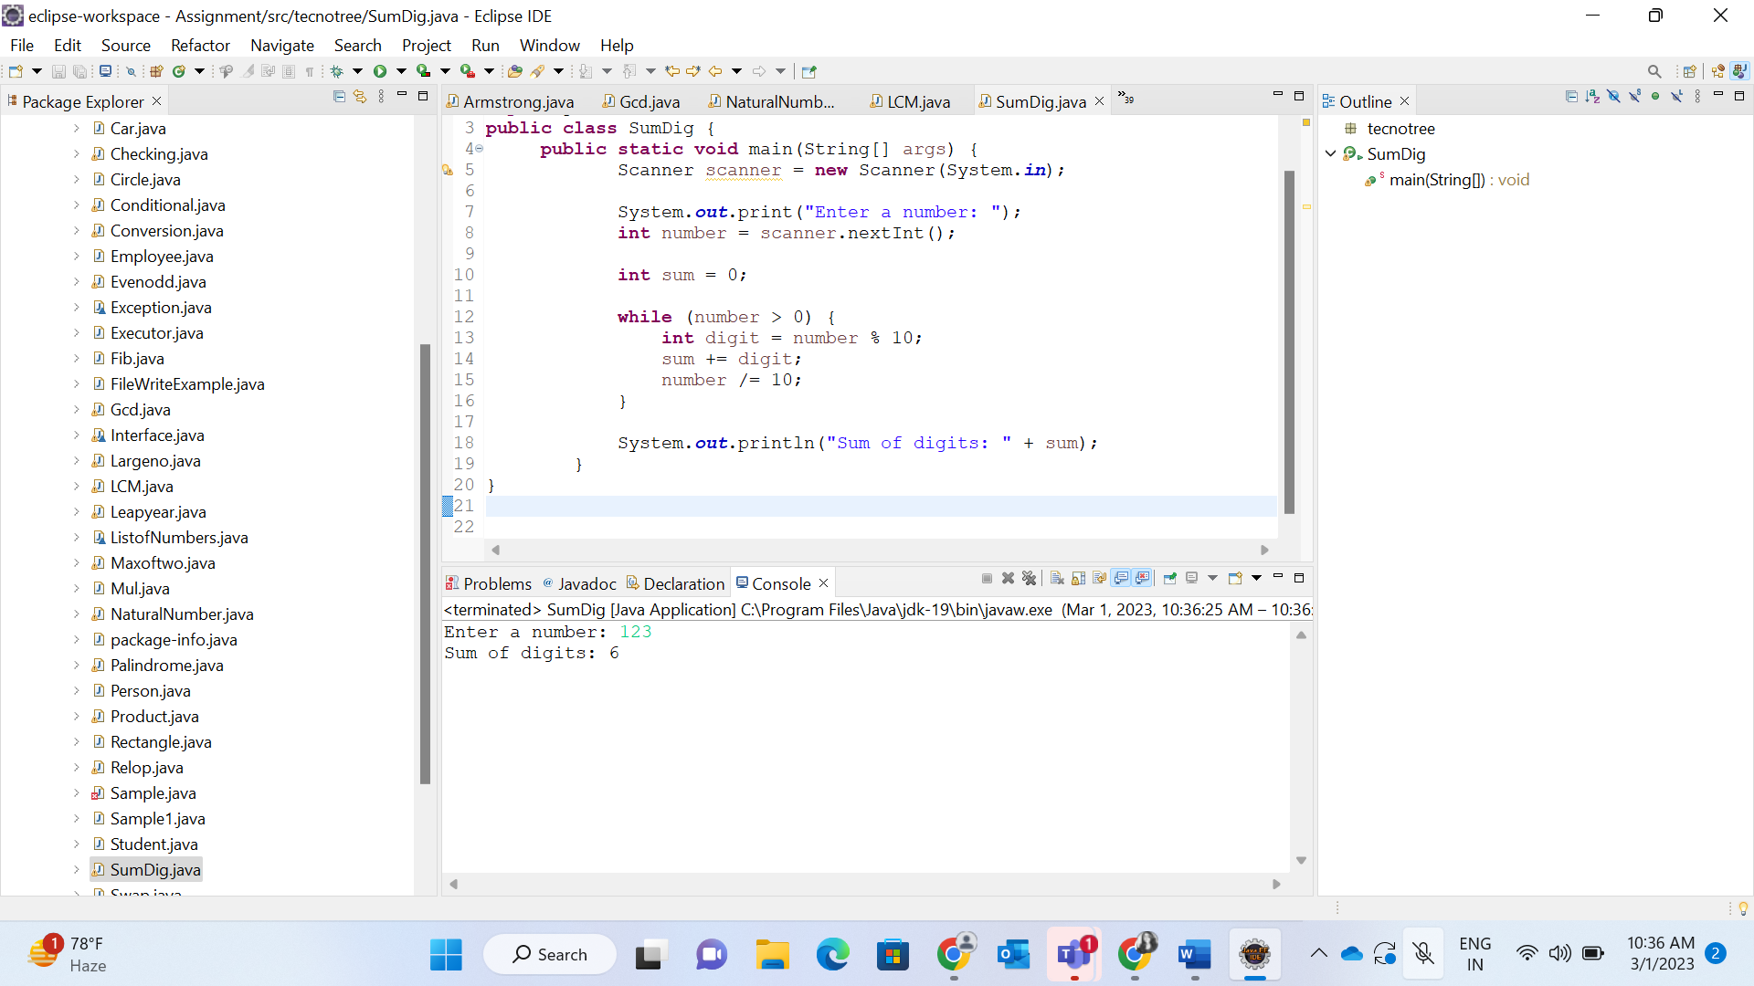

9.Write a program to reverse the String.

<https://codeshare.io/Ad1Nvl>

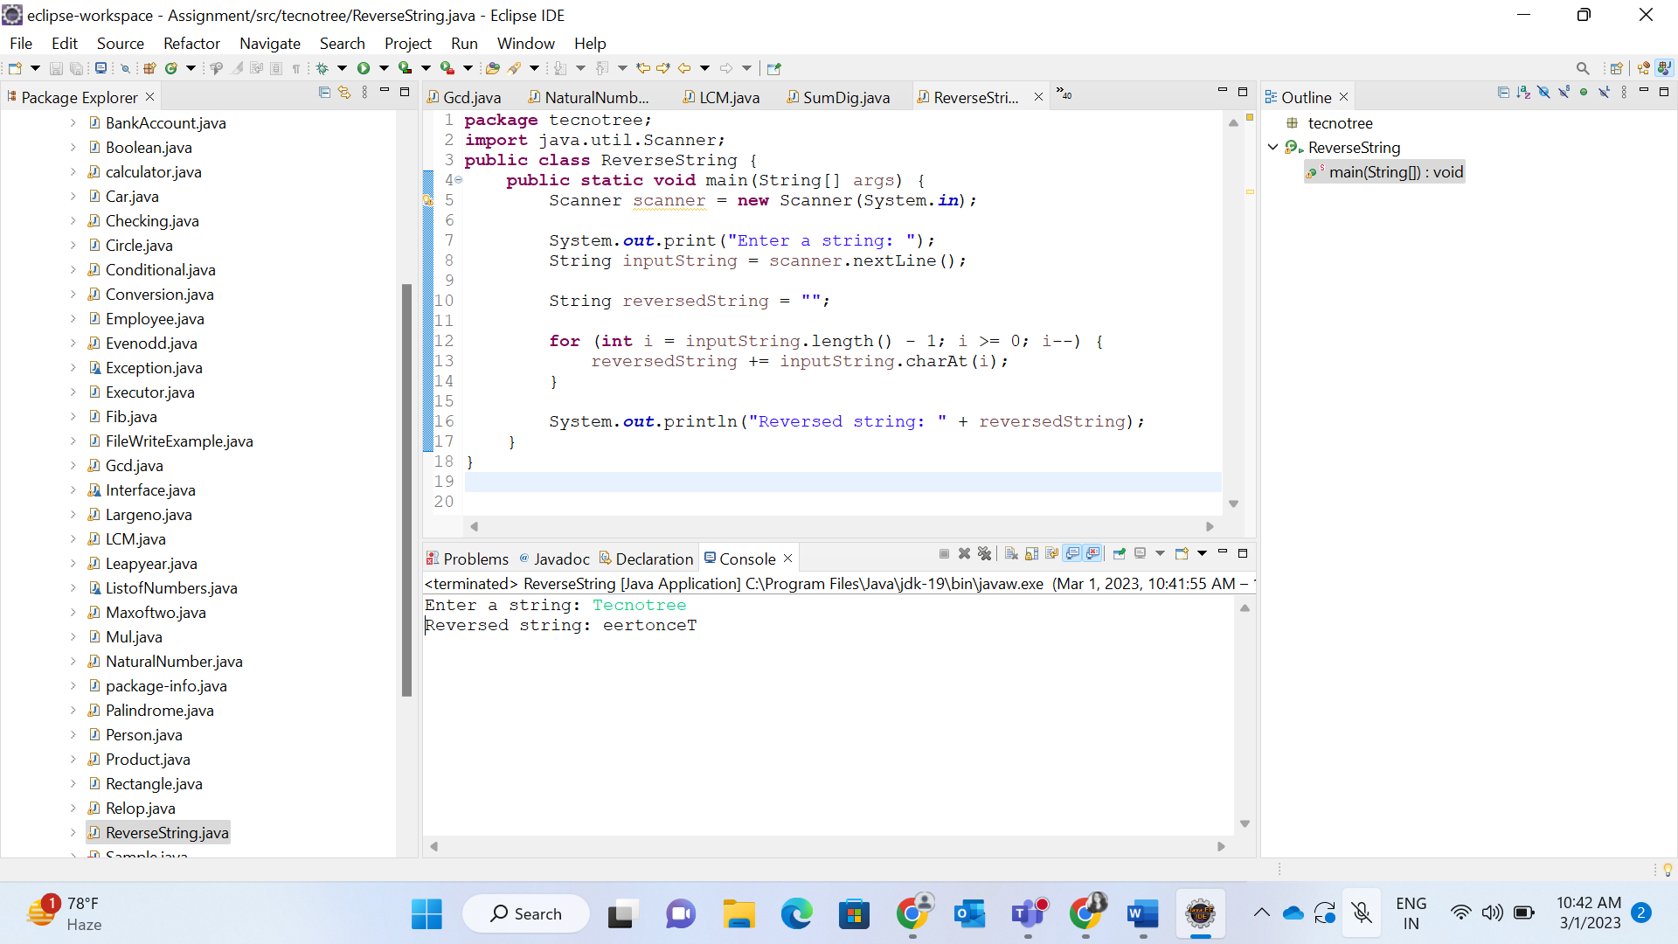

10.Write a java program to print all the first n prime numbers where n will be given as input.

<https://codeshare.io/j0dPDR>

